Statement of Work – Frontier Airlines Agentic Voicebot Implementation
This Statement of Work (SOW) outlines the goals, requirements, milestones, resources, dependencies, and mutual responsibilities between Full Potential Solutions (FPS) and Frontier Airlines for the design, development, and deployment of the Frontier Agentic Voicebot. Both parties are committed to a successful delivery of the MVP version of the solution that provides value to the business and customers.

1. Project Goal
Deploy the Agentic Voicebot with the MVP feature set during the week of Jan 7-14 to enhance customer experience through AI-powered voice interaction.

2. Scope of Work
FPS will design, develop, and deliver the Frontier Agentic Voicebot MVP solution. This includes configuration, integration, testing, and deployment activities required to enable AI-based conversational capabilities for Frontier’s inbound customer support number (801-401-9000) for non-Elite and non-24hr customers. The agentic voicebot will perform intent recognition, provide FAQ responses from Frontier’s knowledgebase, handover (when required) to live voice agents with enhanced context (call intent), and collect CSAT and resolution data.
MVP Requirements include:
• Create new voice-only Cognigy endpoint and flow for agentic voicebot (distinct from existing agentic webchat bot)
• Integrate with Cognigy Voice Gateway via IGT’s NICE CXone platform to receive inbound customer calls from CSG’s IVR
• Utilize a Frontier provided Azure AI Speech services Speech-to-Text / Text-to-Speech (STT/TTS) production API key to convert voice to text and vice versa
• Play a welcome message when a call arrives to Cognigy – 'How may I assist you today?' (no DTMF)
• Detect the closest intent based on the customer’s verbal query
• Revise Frontier’s FAQ knowledge base lookup to be compatible for voice
• Optimize agentic voice FAQ responses from the Frontier provided LLM (shorter, conversational tone, remove links, etc.)
• Implement the live agent handover process from Cognigy platform to IGT’s NICE CXone platform via Signal API with CTI metadata (call-ID, ANI, intent, skill-ID) when available
• Provide Cognigy metrics to track when calls are transferred from the Cognigy agentic voice flow to the live agent handover flow
• Recreate relevant error handling and guardrails with similar functionality as the agentic webchat bot (i.e. 20-turns, 1000 character limit)
• Capture Resolution status (Yes/No) and CSAT (1-5) at the end of conversation
• Cognigy metrics provided via established ODATA feed
• Create test plan that details agentic voice test cases and end to end test environment
• Documentation of the agentic voice solution
MVP Design Diagram
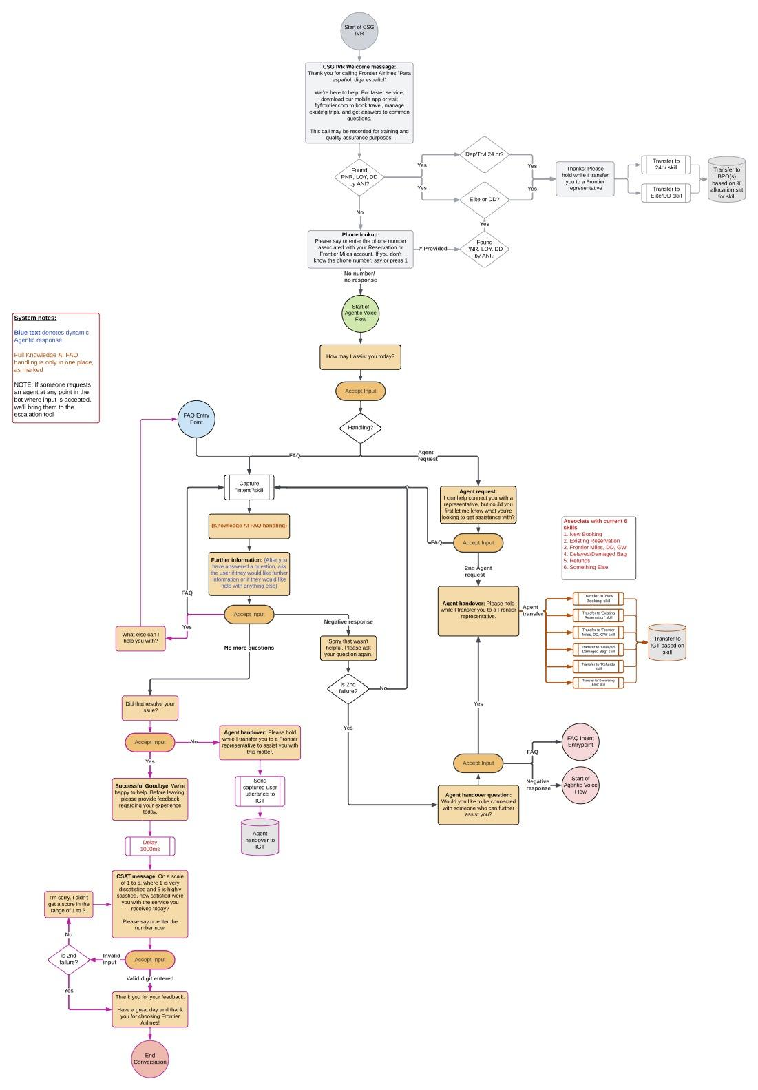
**Frontier to approve the design diagram and verbiage for speech prompts.

Assumptions
• Support only the FAQ feature for MVP, no self-service flows (cancel flight, PNR lookup, etc.)
• We will be using Azure AI Speech for STT/TTS services (Cognigy to recommend exact model, Cognigy will provide temporary STT/TTS API keys for lower environments, Frontier to procure Production STT/TTS API keys from Frontier Cloud team)
• Agent handover is to a live voice agent queue, no live chat agent (no channel switching)
• Enhanced context provided in agent handoff flow is limited to CTI metadata (call-ID, ANI, call-type intent, skill-ID) when available. Providing an AI generated summary is dependent on IGT NICE CXone Agent Desktop compatibility for receiving and displaying the AI summary.
• IGT to identify queue categories to map intents to
• Resolution status and CSAT to be captured requires Frontier review and approval
• No Spanish language support
• No SMS support
• No links support (deeplinks, URLs, etc.)
• No DTMF IVR recreation (except as needed for CSAT functionality described in design)
• Latency is inherent to this voice application (due to STT/TTS processing, LLM response time, network delays, etc.) but will be tested and considered acceptable for use by Frontier in the voice channel
• Except for production-critical issues, no additional development on agentic webchat bot during the agentic voice MVP implementation project
• As detailed in the Dependencies section, Frontier will procure and supply all necessary license keys, APIs, etc. from partners and internal teams to enable the solution for lower and production environments
• Partners (Cognigy, IGT, CSG) will be supportive and responsive in collaborating with FPS
• Partners (IGT, CSG) will provide staging environments for FPS to test with
• Frontier will seek all necessary internal approvals to launch the voicebot into production (i.e. ARB, CAB, etc.)
• No major issues are found during development and testing that impact the MVP solution for production launch

3. Key Milestones
• FPS Draft Proposal: Nov 5
• FPS Final Proposal (SOW): Nov 20
• Frontier SOW Approval: Nov 21
• Frontier Staging Dependencies Complete: Nov 21
Frontier IT team: KnowledgeOwl APIs (as provided for agentic webchat bot)
Frontier Cloud team: OpenAI LLM (gpt-4o-mini) API key (as provided for agentic webchat bot)
• Cognigy Staging Dependencies Phase 1 Complete: Dec 1
Cognigy provided Cognigy VoiceGateway license and Azure AI Speech STT/TTS keys for lower environments (Dev/QA/UAT), provide templates and prompts specific to agentic voice configuration to FPS.
• Cognigy Staging Dependencies Phase 2 Complete: Dec 8
Provision VoiceGateway instance and connect to IGT SIP trunks for lower environments (Dev/QA/UAT), assign at least 8 virtual numbers to SIP trunks for testers to dial, create SIP test flow.
• IGT Staging Dependencies Complete: Dec 8
Accept 800 number for testing from CSG IVR, Provision SIP trunks to Cognigy (via NICE CXone platform) for lower environments (Dev/QA/UAT), support Signal API to deliver CTI and enhanced context (call-ID, ANI, intent, skill-ID) to NICE CXone platform, identify queue categories to map intents to, provide NICE CXone staging environment for testing, provide 8 inbound DID test numbers mapped to test SIP trunks.
• FPS Development of Knowledgebase Functionality Complete: Dec 8
• Frontier Production Dependencies Complete: Dec 8
Frontier IT team: ARB review and approval, Production KnowledgeOwl APIs (as provided for agentic webchat bot)
• FPS Development of Partner Integrations Complete: Dec 12
• FPS QA Testing: Dec 8–12
Execute Agentic Voice test plan in QA environment for end to end solution.
• CSG Staging Dependencies Complete: Dec 15
In the staging environment, configure IVR call routing (via SIP REFER) to IGT NICE CXOne platform with 800 test number for the new “Unknown” call-type.

• Cognigy Production Dependencies Complete: Dec 15
Provision licensed VoiceGateway production instance and connect to IGT SIP trunks for production environment, assign at least 2 virtual numbers to SIP trunks for testers to dial, create SIP test flow.
• IGT Production Dependencies Complete: Dec 15
Accept 800 number for production from CSG IVR, Provision SIP trunks to Cognigy (via NICE CXone platform) for production environment, support Signal API to deliver CTI and enhanced context (call-ID, ANI, intent, skill-ID) to NICE CXone platform, provide 2 inbound DID test numbers mapped to production SIP trunks.
• Frontier UAT Testing: Dec 15–19
Execute Agentic Voice test plan in UAT environment for end to end solution.
• CSG Production Dependencies Complete: Dec 17
In the production environment, configure IVR call routing (via SIP REFER) to IGT NICE CXOne platform for the new “Unknown” call-type. The percentage of calls sent to Cognigy (via IGT) as unknown callers for the agentic voice experience is configurable.
• Frontier UAT Approval: Dec 19
• Frontier Production Dependencies Complete: Jan 5
Frontier Cloud team: Provide production STT/TTS API keys (Azure AI Speech), OpenAI LLM license credentials (as provided for agentic webchat bot)
• Frontier Production Go-Live Approval (CAB): Jan 6
• FPS Production Deployment: Jan 7-14
Deploy solution in production, sanity testing, support, monitoring.

4. Systems in Scope
• CSG Telephony system (existing IVR, hosting inbound customer support number)
• IGT NICE CXone Telephony system (SIP trunks, DIDs, call queues, agent desktop)
• KnowledgeOwl Knowledgebase (via existing API)
• Cognigy platform with Knowledge AI and VoiceGateway licensed features
• Speech-to-Text / Text-to-Speech service (Azure AI Speech - model TBD)
• Azure OpenAI LLM (gpt-4o-mini)
**Systems must be available in lower and production environments

5. Dependencies
The following dependencies must be completed by Frontier Airlines and all partners (Cognigy, CSG, IGT) to enable FPS to meet the agreed timelines:
• IGT: Accept 800 number from CSG IVR, Provision SIP trunks to Cognigy (via NICE CXone platform) for all environments (Dev/QA/UAT/Prod), support Signal API to deliver CTI and enhanced context (call-ID, ANI, intent, skill-ID, AI generated summary) to NICE CXone platform, identify queue categories to map intents to, provide NICE CXone staging environment for testing, provide 8 inbound DID test numbers mapped to SIP trunks.
• Cognigy: Provide temporary STT/TSS API keys for lower environments (Dev/QA/UAT), provide templates and prompts specific to agentic voice configuration, provision VoiceGateway instance and connect to IGT SIP trunks for all environments (Dev/QA/UAT/Prod), assign at least 8 virtual numbers to SIP trunks for testers to dial, create SIP test flow.
• Frontier IT team: ARB review and approval, KnowledgeOwl APIs (as provided for agentic webchat bot), CAB approval
• Frontier Cloud team: Provide production STT/TTS license keys (Azure AI Speech), OpenAI LLM license credentials (as provided for agentic webchat bot)
• CSG: Configure IVR call routing (via SIP REFER) to IGT NICE CXOne platform for a new “Unknown” call-type for non-Elite and non-24 hr customers. The percentage of calls sent to Cognigy (via IGT) as unknown callers for the agentic voice experience is configurable.

**FPS will not be responsible for delays caused by partners that affect project timelines.

6. Responsibilities
FPS
• Deliver MVP requirements
• Conduct QA testing and support Frontier UAT
• Provide clear communication of project tasks, timelines, risks and dependencies
Frontier
• Provide necessary system access to support agentic voice solution
• Expedited approval of requirements, design, and testing
• Coordinate with internal teams and partners (IT, Cloud, Agents, IGT, CSG)
Cognigy
• Configure VoiceGateway with SIP trunks
• Provide necessary technical support for integration with NICE CXone
• Be supportive and responsive in collaborating with FPS in completing tasks and attending meetings
IGT
• Configure SIP trunks in NICE CXone
• Provide staging environment and inbound DID test numbers to map to Cognigy
• Be supportive and responsive in collaborating with FPS in completing tasks and attending meetings
CSG
• Host IVR and route call-type “Unknown” for non-elite and non-24 hour customers to IGT NICE CXone platform
• Configurable amount of IVR traffic delivered to IGT
• Be supportive and responsive in collaborating with FPS in completing tasks and attending meetings

7. Change Control
Any modification to the agreed scope, timeline, or deliverables will be managed through a mutual written change control process. Both FPS and Frontier will assess the impact of requested changes on effort, cost, and project schedule before implementation.

8. Cost Summary
The fixed cost for the MVP requirements is $35,000 for the following FPS services: design, development, solution architecture, project management, and QA.

9. Penalties and Exceptions
FPS is committed to meeting the agreed project delivery dates. However, if delays occur due to dependencies outside FPS control (by Frontier, Cognigy, CSG, IGT, etc.) then FPS shall not be liable for penalties or damages. Any such delays will be discussed collaboratively, and schedules will be adjusted accordingly. If FPS does not deliver on the MVP requirements they control by Jan 5, then FPS will provide Frontier a one time credit of $5,250 on the next invoice, thus reducing the agentic voice MVP project fee to $29,750.

10. Acceptance
This Statement of Work represents a shared commitment between Full Potential Solutions and Frontier Airlines. Both parties agree to collaborate and fulfill their respective responsibilities to ensure successful implementation of the Frontier Agentic Voicebot MVP.
___________________________ ___________________________
Full Potential Solutions Frontier Airlines
Date: ______________________ Date: ______________________

